WEEK – 6

**REACT - Mandatory Hands On**

1. **MyfirstReact**

**App.js**

function App() {

  return (

    <h1> Welcome the first session of React</h1>

  );

}

export default App;

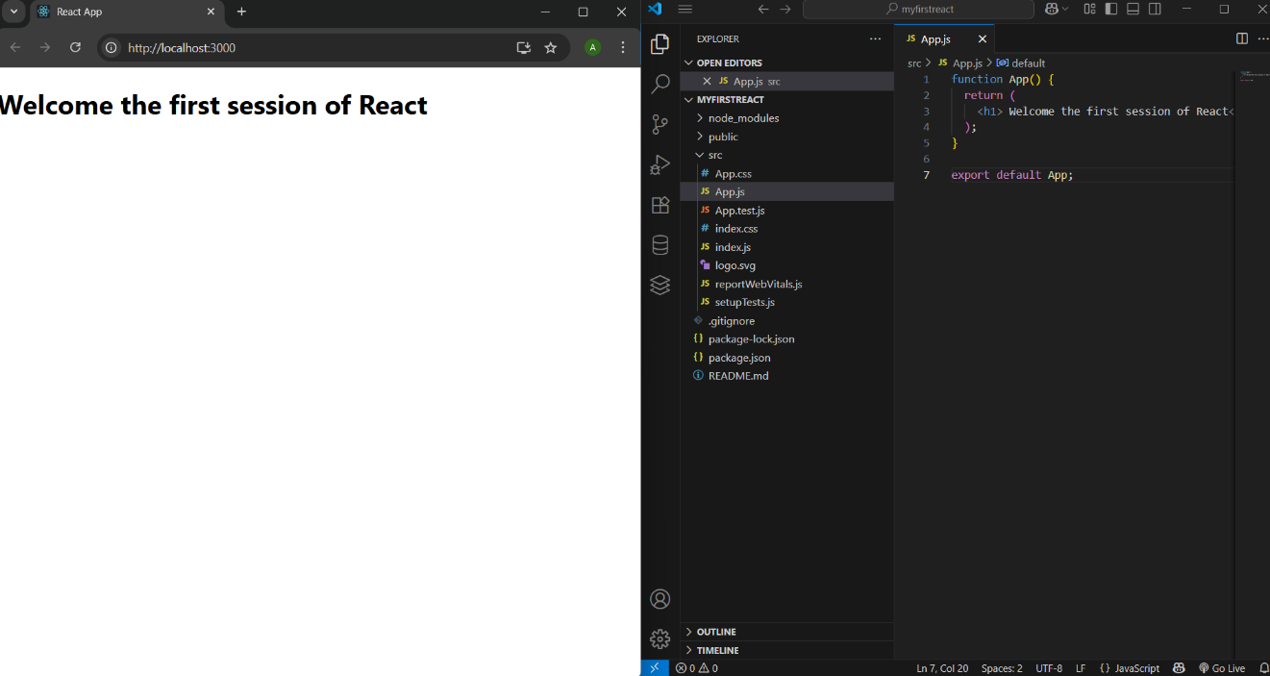

1. **StudentApp**

**Home.js**

import React, { Component } from 'react';

class Home extends Component {

  render() {

    return (

      <div>

        <h3>Welcome to the Home Page of Student Management Portal</h3>

      </div>

    );

  }

}

export default Home;

**About.js**

import React, { Component } from 'react';

class About extends Component {

  render() {

    return (

      <div>

        <h3>Welcome to the About Page of Student Management Portal</h3>

      </div>

    );

  }

}

export default About;

**Contact.js**

import React, { Component } from 'react';

class Contact extends Component {

  render() {

    return (

      <div>

        <h3>Welcome to the Contact Page of Student Management Portal</h3>

      </div>

    );

  }

}

export default Contact;

**App.js**

import React from 'react';

import Home from './Components/Home';

import About from './Components/About';

import Contact from './Components/Contact';

function App() {

  return (

    <div>

      <Home />

      <About />

      <Contact />

    </div>

  );

}

export default App;

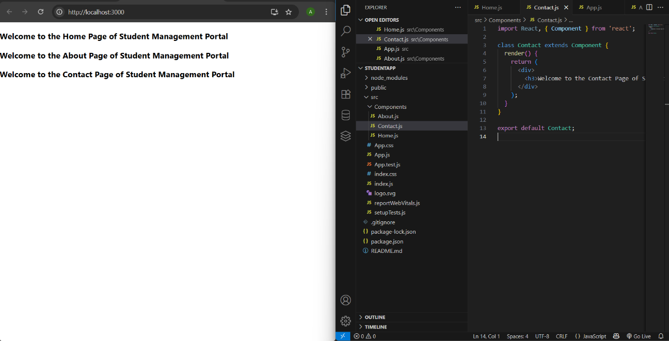

1. **ScoreCalculatorApp**

**CalculateScore.js**

import React from 'react';

import'../Stylesheets/mystyle.css'

const percentToDecimal= (decimal)=>{

    return(decimal.toFixed(2)+'%')

}

const calcScore=(total,goal)=>{

    return percentToDecimal(total/goal)

}

export const CalculateScore = ({ Name, School, total, goal }) => (

  <div className="formatstyle">

    <h1><font color="Brown">Student Details:</font></h1>

    <div className="Name">

      <b> <span> Name: </span> </b>

      <span>{Name}</span>

    </div>

    <div className="School">

      <b> <span> School: </span> </b>

      <span>{School}</span>

    </div>

    <div className="Total">

      <b><span>Total:</span> </b>

      <span>{total}</span>

      <span>Marks</span>

    </div>

    <div className="Score">

      <b>Score:</b>

      <span>

        {calcScore(

          total,

          goal

        )}

      </span>

    </div>

  </div>

);

**Mystyle.css**

.Name

{

    font-weight:300;

    color:blue;

}

.School

{

    color:crimson;

}

.Total

{

    color:darkmagenta;

}

.formatstyle

{

    text-align:center;

    font-size:large;

}

.Score

{

    color:forestgreen;

}

**App.js**

import React from 'react';

import {CalculateScore} from '../src/Components/CalculateScore';

function App() {

  return (

    <div>

      <CalculateScore

        Name={"Steeve"}

        School={"DNV Public School"}

        total={284}

        goal={3}

      />

    </div>

  )

}

export default App;

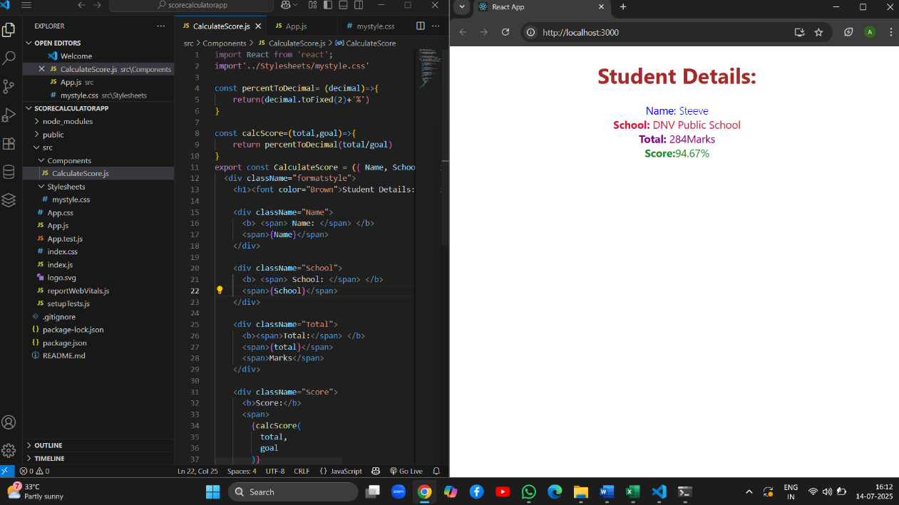

1. **Bloggapp**

**Post.js**

import React from 'react';

const Post = ({ title, body }) => {

  return (

    <div style={{ marginBottom: '20px' }}>

      <h2>{title}</h2>

      <p>{body}</p>

    </div>

  );

};

export default Post;

**Posts.js**

import React, { Component } from 'react';

import Post from './Post';

class Posts extends Component {

  constructor(props) {

    super(props);

    this.state = {

      posts: [],

      hasError: false,

    };

  }

  loadPosts = () => {

    fetch('https://jsonplaceholder.typicode.com/posts')

      .then((response) => response.json())

      .then((data) => {

        this.setState({ posts: data });

      })

      .catch((error) => {

        console.error("Error fetching posts:", error);

        this.setState({ hasError: true });

      });

  };

  componentDidMount() {

    this.loadPosts();

  }

  componentDidCatch(error, info) {

    alert("An error occurred: " + error.message);

    this.setState({ hasError: true });

  }

  render() {

    const { posts, hasError } = this.state;

    if (hasError) {

      return <h1>Something went wrong!</h1>;

    }

    return (

      <div>

        <h1>Blog Posts</h1>

        {posts.map((post) => (

          <Post key={post.id} title={post.title} body={post.body} />

        ))}

      </div>

    );

  }

}

export default Posts;

**App.js**

import React from 'react';

import Posts from './Posts';

function App() {

  return (

    <div className="App">

      <Posts />

    </div>

  );

}

export default App;

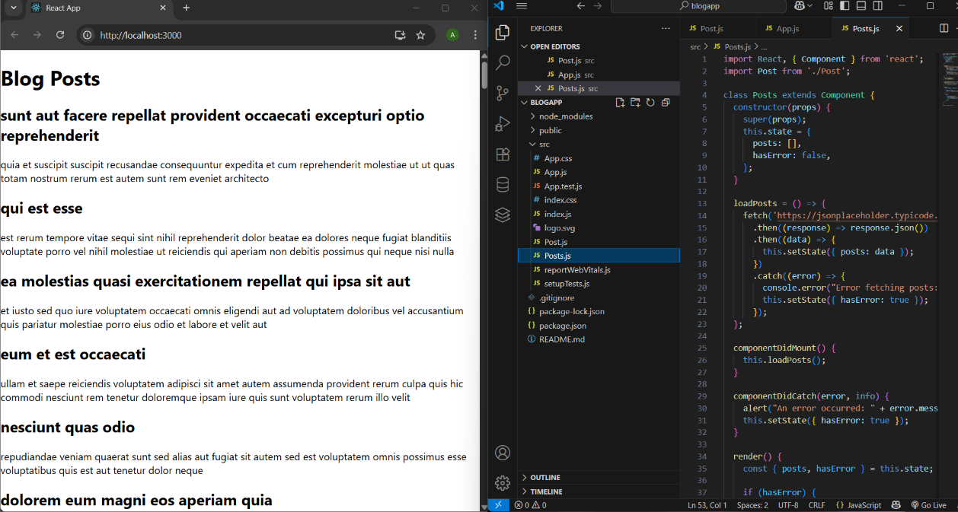

1. **CohortTrackerZip**

**CohortDetails.js**

import React from 'react';

import styles from './CohortDetails.module.css';

const CohortDetails = () => {

  const cohorts = [

    {

      id: 'INTADMDF10',

      track: '.NET FSD',

      startedOn: '22-Feb-2022',

      status: 'Scheduled',

      coach: 'Aathma',

      trainer: 'Jojo Jose',

    },

    {

      id: 'ADM21JF014',

      track: 'Java FSD',

      startedOn: '10-Sep-2021',

      status: 'Ongoing',

      coach: 'Apoorv',

      trainer: 'Elisa Smith',

    },

    {

      id: 'CDBJF21025',

      track: 'Java FSD',

      startedOn: '24-Dec-2021',

      status: 'Ongoing',

      coach: 'Aathma',

      trainer: 'John Doe',

    }

  ];

  return (

    <div>

      <h2>Cohorts Details</h2>

      {cohorts.map((cohort, index) => (

        <div key={index} className={styles.box}>

          <h3 style={{ color: cohort.status === 'Ongoing' ? 'green' : 'blue' }}>

            {cohort.id} - {cohort.track}

          </h3>

          <dl>

            <dt>Started On</dt>

            <dd>{cohort.startedOn}</dd>

            <dt>Current Status</dt>

            <dd>{cohort.status}</dd>

            <dt>Coach</dt>

            <dd>{cohort.coach}</dd>

            <dt>Trainer</dt>

            <dd>{cohort.trainer}</dd>

          </dl>

        </div>

      ))}

    </div>

  );

};

export default CohortDetails;

**CohortDetails.module.css**

.box {

  width: 300px;

  display: inline-block;

  margin: 10px;

  padding: 10px 20px;

  border: 1px solid black;

  border-radius: 10px;

}

dt {

  font-weight: 500;

}

